PRESIDENT’S OFFICE
REGIONAL ADMINISTRATION AND LOCAL GOVERNMENT
FORM IV TAHOSSA NORTHWESTERN ZONE MOCK EXAMINATION 2025
031/2A PHYSICS 2A
(ACTUAL PRACTICAL A)
TIME: 2:30HRS AUGUST 2025
INSTRUCTIONS
- This paper consists of two (2) questions.
- Answer all questions.
- Each questions carries twenty-five (25) marks.
- All writings should be in blue or black ink. Except for diagrams which must be in pencil.
- Mathematical tables and non-programmable calculators may be used.
- Communication devices and unauthorized materials are not allowed in the examination room.
- Write your examination Number on every page of your answer booklet(s)
The following information may be useful
Pie $π=3.14.$

- The aim of this experiment is to determine the CRITICAL ANGLE of the glass block for light passing from air to glass.proceed as follows.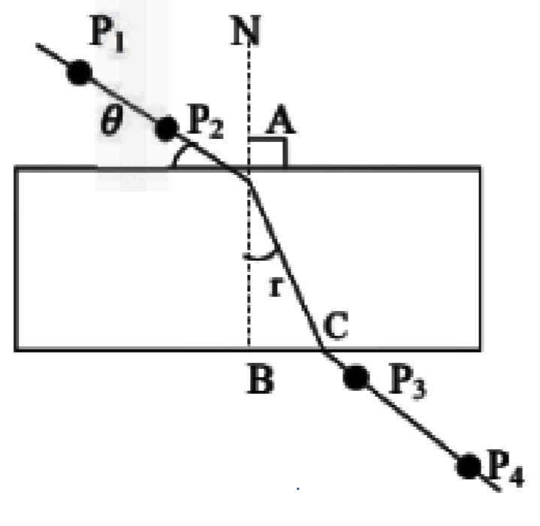

- Place the rectangular glass block flat on the drawing paper fixed on the board. Using a sharp pencil trace outline of the block, remove the block and draw a normal NAB near the left end of the block using a $θ=20°.$ from protector of the surface of the block. Erect two pins P1 and P2 on this at suitable distance apart. Replace the block erect two pins P3 and P4 at position which appear to be in straight line with the other two pins as seen through the block. Again, remove the block and measure the value of an angle r.
- Repeat procedure above for value of $θ=30°,40° , 50°, and 60°$each time making your drawing on fresh part of the drawing paper. Record clearly the value of $θ°,r°,cos θ and$sin r.
- Plot a graph of cos $θ$ (Vertical axis) against sin r (horizontal axis)
- Determine the slope n of the graph.
- What is the physical meanings of the slope you have calculated in (d) above?
- From your graph determine critical angle of the glass block. Given $\frac{1}{∩}$ = sin $c°$
- State any two sources of errors and precaution taken in this experiment.
- The figure below shows a meter bridge with two resistance X and R connected for comparison purpose. X is unknown resistance while R is a known resistance.

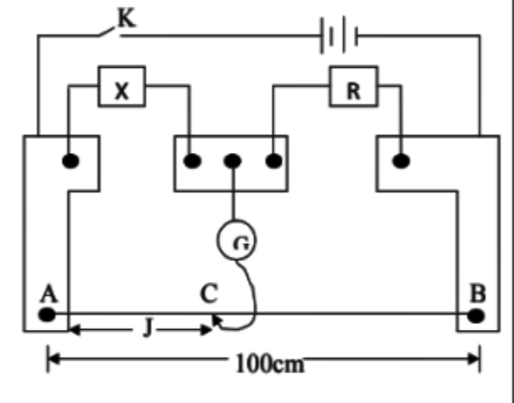

The dry cell drives the current through X, R and the bridge wire AB. K is the switch, G and J are respectively a galvanometer and Jokey A balance point C is found for different values of resistance R. corresponding values of R.
- Complete the table by filling the value R,d and ${100}/d$
- Plot a graph of R against ${100}/d$
- Find the slope S of the graph
- Determine the intercept Ro on R-Axis.
- Deduce value of X.
- Suggest the suitable title for this experiment.

